I. X-ray Analysis Data of Compound 11

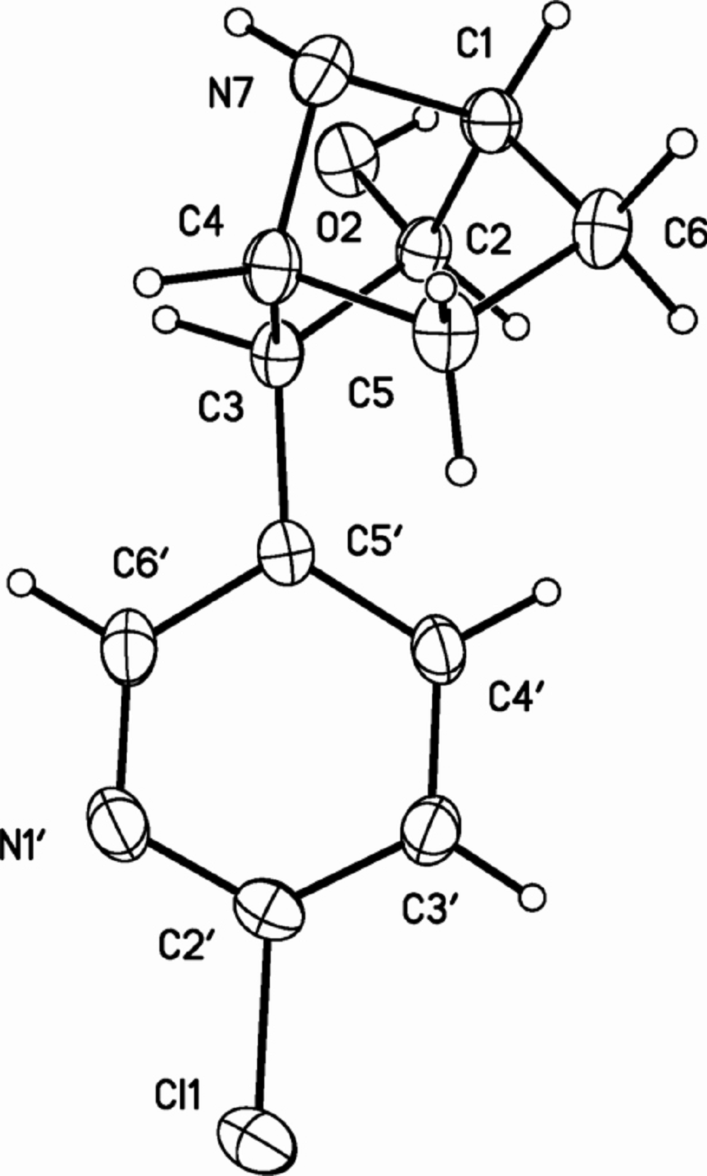

Table 1. Crystal data and structure refinement for gu92m.
Identification code gu92m
Empirical formula C₁₁ H₁₃ Cl N₂ O
Formula weight 224.68
Temperature 93(2) K
Wavelength 0.71073 Å
Crystal system Orthorhombic
Space group P2₁2₁2₁
Unit cell dimensions a = 9.595(1) Å α= 90°.
b = 9.689(1) Å β= 90°.
c = 11.318(1) Å γ = 90°.
Volume 1052.17(14) Å3
Z 4
Density (calculated) 1.418 Mg/m3
Absorption coefficient 0.336 mm-1
F(000) 472
Crystal size 0.56 x 0.18 x 0.11 mm3
Theta range for data collection 2.77 to 28.28°.
Index ranges -12<=h<=11, -12<=k<=12, -15<=l<=14
Reflections collected 8373
Independent reflections 2573 [R(int) = 0.0395]
Completeness to theta = 28.28° 99.5 %
Absorption correction None
Max. and min. transmission 0.963 and 0.828
Refinement method Full-matrix least-squares on F2
Data / restraints / parameters 2573 / 0 / 142
Goodness-of-fit on F2 1.036
Final R indices [I>2sigma(I)] R1 = 0.0384, wR2 = 0.0928
R indices (all data) R1 = 0.0441, wR2 = 0.0948
Absolute structure parameter -0.21(8)
Largest diff. peak and hole 0.352 and -0.181 e.Å-3
Table 2. Atomic coordinates ( x 104) and equivalent isotropic displacement parameters (Å2x 103)
for gu92m. U(eq) is defined as one third of the trace of the orthogonalized Uij tensor.
________________________________________________________________________________
x y z U(eq)
________________________________________________________________________________
Cl(1) 377(1) 6027(1) 5013(1) 32(1)
C(1) -838(2) 6409(2) -1867(2) 22(1)
C(2) 90(2) 7257(2) -1034(2) 21(1)
O(2) 1195(1) 7916(2) -1657(1) 28(1)
C(3) 742(2) 6118(2) -248(2) 21(1)
C(4) 101(2) 4778(2) -786(2) 23(1)
C(5) -1442(2) 4649(2) -452(2) 25(1)
C(6) -2094(2) 5843(2) -1173(2) 25(1)
N(7) -17(2) 5118(2) -2060(2) 25(1)
N(1') 1540(2) 5515(2) 2963(2) 30(1)
C(2') 492(2) 6169(2) 3474(2) 24(1)
C(3') -516(2) 6909(2) 2883(2) 28(1)
C(4') -456(2) 6936(2) 1664(2) 26(1)
C(5') 602(2) 6236(2) 1078(2) 20(1)
C(6') 1583(2) 5566(2) 1780(2) 28(1)
________________________________________________________________________________
Table 3. Bond lengths [Å] and angles [°] for gu92m.
_____________________________________________________

Cl(1)-C(2') 1.750(2)
C(1)-N(7) 1.494(2)
C(1)-C(2) 1.536(3)
C(1)-C(6) 1.539(3)
C(2)-O(2) 1.424(2)
C(2)-C(3) 1.549(3)
C(3)-C(5') 1.510(2)
C(3)-C(4) 1.561(3)
C(4)-N(7) 1.483(3)
C(4)-C(5) 1.533(2)
C(5)-C(6) 1.548(3)
N(1')-C(2') 1.323(3)
N(1')-C(6') 1.340(3)
C(2')-C(3') 1.378(3)
C(3')-C(4') 1.381(3)
C(4')-C(5') 1.390(3)
C(5')-C(6') 1.392(3)

N(7)-C(1)-C(2) 103.44(15)
N(7)-C(1)-C(6) 100.93(15)
C(2)-C(1)-C(6) 109.37(16)
O(2)-C(2)-C(1) 111.58(16)
O(2)-C(2)-C(3) 107.62(14)
C(1)-C(2)-C(3) 101.83(15)
C(5')-C(3)-C(2) 118.74(16)
C(5')-C(3)-C(4) 114.55(16)
C(2)-C(3)-C(4) 102.09(14)
N(7)-C(4)-C(5) 100.63(15)
N(7)-C(4)-C(3) 103.01(15)
C(5)-C(4)-C(3) 110.60(16)
C(4)-C(5)-C(6) 101.49(16)
C(1)-C(6)-C(5) 102.62(14)
C(4)-N(7)-C(1) 94.79(14)
C(2')-N(1')-C(6') 116.26(18)
N(1')-C(2')-C(3') 124.83(19)
N(1')-C(2')-Cl(1) 116.46(15)
C(3')-C(2')-Cl(1) 118.69(16)
C(2')-C(3')-C(4') 117.75(19)
C(3')-C(4')-C(5') 119.91(18)
C(4')-C(5')-C(6') 116.64(18)
C(4')-C(5')-C(3) 125.16(17)
C(6')-C(5')-C(3) 118.18(17)
N(1')-C(6')-C(5') 124.56(19)

_____________________________________________________________
Symmetry transformations used to generate equivalent atoms:

Table 4. Anisotropic displacement parameters (Å2x 103) for gu92m. The anisotropic
displacement factor exponent takes the form: -2π2[ h2 a*2U11 + ... + 2 h k a* b* U12 ]
______________________________________________________________________________
U11 U22 U33 U23 U13 U12
______________________________________________________________________________
Cl(1) 44(1) 28(1) 25(1) 2(1) -6(1) 3(1)
C(1) 22(1) 20(1) 24(1) 1(1) 0(1) 1(1)
C(2) 18(1) 19(1) 26(1) 2(1) 3(1) -1(1)
O(2) 22(1) 27(1) 35(1) 10(1) 2(1) -5(1)
C(3) 16(1) 19(1) 27(1) 2(1) 1(1) 1(1)
C(4) 21(1) 17(1) 30(1) 0(1) 1(1) 3(1)
C(5) 20(1) 19(1) 35(1) 2(1) 0(1) -2(1)
C(6) 17(1) 23(1) 34(1) -1(1) 0(1) 1(1)
N(7) 22(1) 24(1) 28(1) -4(1) 3(1) 3(1)
N(1') 29(1) 31(1) 31(1) 0(1) -8(1) 7(1)
C(2') 29(1) 20(1) 22(1) 2(1) -4(1) -4(1)
C(3') 24(1) 28(1) 31(1) 5(1) 5(1) 4(1)
C(4') 21(1) 27(1) 29(1) 7(1) -1(1) 5(1)
C(5') 18(1) 17(1) 25(1) 1(1) -1(1) -2(1)
C(6') 21(1) 28(1) 34(1) -2(1) -3(1) 6(1)
______________________________________________________________________________
Table 5. Hydrogen coordinates ( x 104) and isotropic displacement parameters (Å2x 10 3)
for gu92m.
________________________________________________________________________________
x y z U(eq)
________________________________________________________________________________

H(1A) -1097 6901 -2612 26
H(2A) -465 7931 -558 25
H(2O) 850(30) 8630(30) -2020(20) 33
H(3A) 1762 6099 -428 25
H(4A) 658 3927 -623 27
H(5A) -1585 4780 407 30
H(5B) -1828 3744 -691 30
H(6A) -2829 5500 -1713 30
H(6B) -2495 6557 -648 30
H(7) 820(20) 5290(30) -2370(20) 29
H(3'A) -1229 7385 3300 33
H(4'A) -1137 7432 1227 31
H(6'A) 2334 5114 1394 33
________________________________________________________________________________
Table 6. Torsion angles [°] for gu92m.
________________________________________________________________
N(7)-C(1)-C(2)-O(2) 78.80(18)
C(6)-C(1)-C(2)-O(2) -174.31(16)
N(7)-C(1)-C(2)-C(3) -35.75(18)
C(6)-C(1)-C(2)-C(3) 71.14(17)
O(2)-C(2)-C(3)-C(5') 116.92(17)
C(1)-C(2)-C(3)-C(5') -125.63(17)
O(2)-C(2)-C(3)-C(4) -116.05(16)
C(1)-C(2)-C(3)-C(4) 1.39(17)
C(5')-C(3)-C(4)-N(7) 163.22(14)
C(2)-C(3)-C(4)-N(7) 33.54(16)
C(5')-C(3)-C(4)-C(5) 56.4(2)
C(2)-C(3)-C(4)-C(5) -73.27(19)
N(7)-C(4)-C(5)-C(6) -39.23(19)
C(3)-C(4)-C(5)-C(6) 69.1(2)
N(7)-C(1)-C(6)-C(5) 33.09(19)
C(2)-C(1)-C(6)-C(5) -75.50(19)
C(4)-C(5)-C(6)-C(1) 3.4(2)
C(5)-C(4)-N(7)-C(1) 59.81(17)
C(3)-C(4)-N(7)-C(1) -54.44(15)
C(2)-C(1)-N(7)-C(4) 56.03(16)
C(6)-C(1)-N(7)-C(4) -57.14(16)
C(6')-N(1')-C(2')-C(3') -1.5(3)
C(6')-N(1')-C(2')-Cl(1) 176.61(17)
N(1')-C(2')-C(3')-C(4') 2.1(3)
Cl(1)-C(2')-C(3')-C(4') -175.99(16)
C(2')-C(3')-C(4')-C(5') -0.3(3)
C(3')-C(4')-C(5')-C(6') -1.8(3)
C(3')-C(4')-C(5')-C(3) 176.49(19)
C(2)-C(3)-C(5')-C(4') 25.8(3)
C(4)-C(3)-C(5')-C(4') -95.1(2)
C(2)-C(3)-C(5')-C(6') -155.90(18)
C(4)-C(3)-C(5')-C(6') 83.2(2)
C(2')-N(1')-C(6')-C(5') -0.9(3)
C(4')-C(5')-C(6')-N(1') 2.5(3)
C(3)-C(5')-C(6')-N(1') -175.9(2)
________________________________________________________________
Symmetry transformations used to generate equivalent atoms:

Table 7. Hydrogen bonds for gu92m [Å and °].
____________________________________________________________________________
D-H...A d(D-H) d(H...A) d(D...A) <(DHA)
____________________________________________________________________________
O(2)-H(2O)...N(7)#1 0.87(3) 1.95(3) 2.818(2) 175(2)
N(7)-H(7)...N(1')#2 0.89(2) 2.67(2) 3.392(2) 138.0(19)
____________________________________________________________________________
Symmetry transformations used to generate equivalent atoms:
#1 -x,y+1/2,-z-1/2 #2 -x+1/2,-y+1,z-1/2

####===The End
II. X-ray Analysis Data of Compound 4b

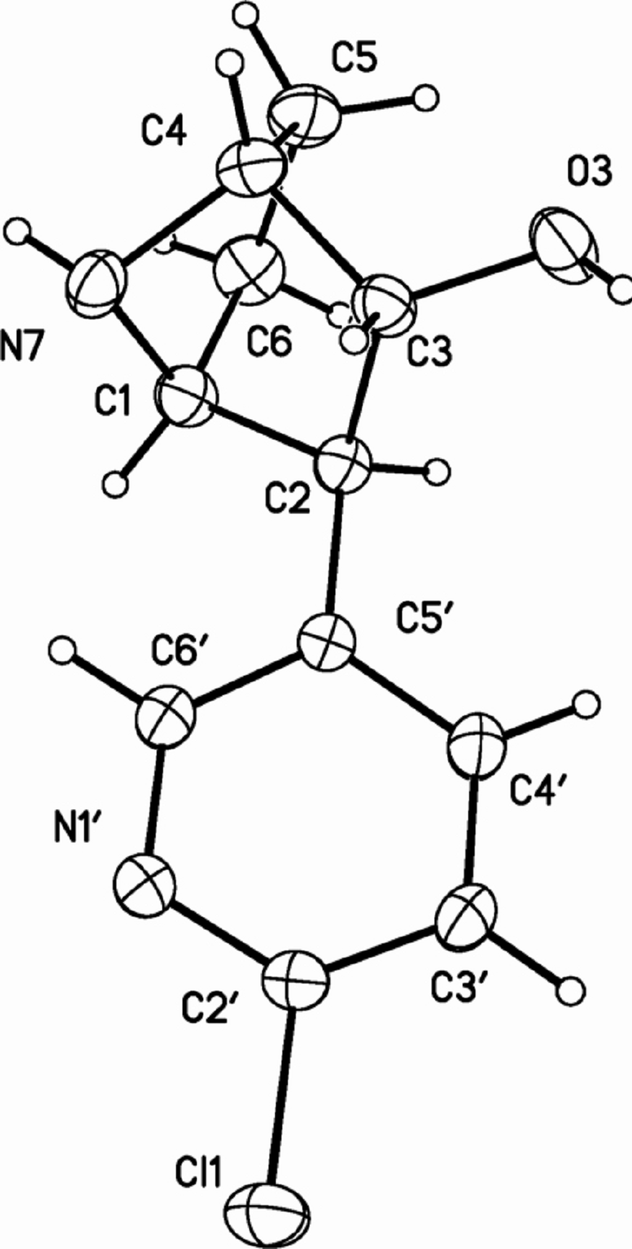

Table 1. Crystal data and structure refinement for gu97m.
Identification code gu97m
Empirical formula C₁₁ H₁₃ Cl N₂ O
Formula weight 224.68
Temperature 293(2) K
Wavelength 1.54178 Å
Crystal system Monoclinic
Space group P2(1)/n
Unit cell dimensions a = 15.036(1) Å α= 90°.
b = 9.633(1) Å β= 107.824(10)°.
c = 15.554(1) Å γ = 90°.
Volume 2144.50(6) Å3
Z 8
Density (calculated) 1.392 Mg/m3
Absorption coefficient 2.942 mm-1
F(000) 944
Crystal size 0.22 x 0.14 x 0.08 mm3
Theta range for data collection 3.58 to 66.91°.
Index ranges -17<=h<=17, -11<=k<=11, -18<=l<=18
Reflections collected 10483
Independent reflections 3690 [R(int) = 0.0468]
Completeness to theta = 66.91° 96.4 %
Absorption correction Multiscan
Max. and min. transmission 0.787 and 0.518
Refinement method Full-matrix least-squares on F2
Data / restraints / parameters 3690 / 0 / 283
Goodness-of-fit on F2 1.040
Final R indices [I>2sigma(I)] R1 = 0.0477, wR2 = 0.1293
R indices (all data) R1 = 0.0593, wR2 = 0.1408
Largest diff. peak and hole 0.167 and -0.231 e.Å-3
Table 2. Atomic coordinates ( x 104) and equivalent isotropic displacement parameters (Å2x 103)
for gu97m. U(eq) is defined as one third of the trace of the orthogonalized Uij tensor.
________________________________________________________________________________
x y z U(eq)
________________________________________________________________________________
Cl(1) 4212(1) -1472(1) -718(1) 76(1)
C(1) 938(2) -2928(2) 1357(2) 58(1)
C(2) 1451(2) -1560(2) 1335(2) 52(1)
C(3) 1921(2) -1280(2) 2367(2) 55(1)
O(3) 1747(1) 57(2) 2645(1) 73(1)
C(4) 1494(2) -2425(3) 2789(2) 60(1)
C(5) 447(2) -2166(3) 2605(2) 70(1)
C(6) 53(2) -2597(3) 1609(2) 71(1)
N(7) 1555(2) -3588(2) 2188(2) 61(1)
N(1') 3200(2) -2667(2) 153(2) 76(1)
C(2') 3396(2) -1463(2) -118(2) 56(1)
C(3') 3009(2) -247(3) 20(2) 74(1)
C(4') 2364(2) -289(2) 480(2) 69(1)
C(5') 2141(2) -1526(2) 809(2) 51(1)
C(6') 2580(2) -2683(3) 617(2) 74(1)
Cl(1A) 4133(1) -1952(1) 4170(1) 76(1)
C(1A) 6116(2) -4105(2) 986(2) 55(1)
C(2A) 6312(2) -2803(2) 1588(2) 51(1)
C(3A) 7395(2) -2881(2) 2017(2) 52(1)
O(3A) 7869(1) -1661(2) 1913(1) 70(1)
C(4A) 7641(2) -4111(2) 1515(2) 58(1)
C(5A) 7471(2) -3721(2) 518(2) 61(1)
C(6A) 6397(2) -3789(3) 135(2) 63(1)
N(7A) 6871(2) -5057(2) 1509(1) 59(1)
N(1'A) 4647(2) -1374(2) 2752(1) 63(1)
C(2'A) 4778(2) -2260(2) 3422(2) 56(1)
C(3'A) 5373(2) -3373(3) 3574(2) 63(1)
C(4'A) 5876(2) -3577(2) 2986(2) 60(1)
C(5'A) 5773(2) -2674(2) 2262(2) 51(1)
C(6'A) 5142(2) -1603(2) 2186(2) 59(1)
________________________________________________________________________________
Table 3. Bond lengths [Å] and angles [°] for gu97m.
_____________________________________________________

Cl(1)-C(2') 1.754(2)
C(1)-N(7) 1.484(3)
C(1)-C(2) 1.532(3)
C(1)-C(6) 1.532(4)
C(2)-C(5') 1.506(3)
C(2)-C(3) 1.568(3)
C(3)-O(3) 1.408(3)
C(3)-C(4) 1.522(3)
C(4)-N(7) 1.480(3)
C(4)-C(5) 1.532(3)
C(5)-C(6) 1.537(4)
N(1')-C(2') 1.299(3)
N(1')-C(6') 1.342(3)
C(2')-C(3') 1.354(3)
C(3')-C(4') 1.371(4)
C(4')-C(5') 1.377(3)
C(5')-C(6') 1.374(3)
Cl(1A)-C(2'A) 1.754(2)
C(1A)-N(7A) 1.491(3)
C(1A)-C(6A) 1.537(3)
C(1A)-C(2A) 1.539(3)
C(2A)-C(5'A) 1.514(3)
C(2A)-C(3A) 1.561(3)
C(3A)-O(3A) 1.409(3)
C(3A)-C(4A) 1.525(3)
C(4A)-N(7A) 1.472(3)
C(4A)-C(5A) 1.539(3)
C(5A)-C(6A) 1.541(4)
N(1'A)-C(2'A) 1.314(3)
N(1'A)-C(6'A) 1.335(3)
C(2'A)-C(3'A) 1.369(3)
C(3'A)-C(4'A) 1.368(4)
C(4'A)-C(5'A) 1.394(3)
C(5'A)-C(6'A) 1.382(3)

N(7)-C(1)-C(2) 101.74(18)
N(7)-C(1)-C(6) 103.1(2)
C(2)-C(1)-C(6) 108.1(2)
C(5')-C(2)-C(1) 117.84(18)
C(5')-C(2)-C(3) 112.5(2)
C(1)-C(2)-C(3) 101.39(17)
O(3)-C(3)-C(4) 112.86(19)
O(3)-C(3)-C(2) 113.8(2)
C(4)-C(3)-C(2) 101.46(18)
N(7)-C(4)-C(3) 99.24(18)
N(7)-C(4)-C(5) 105.4(2)
C(3)-C(4)-C(5) 110.3(2)
C(4)-C(5)-C(6) 101.6(2)
C(1)-C(6)-C(5) 102.5(2)
C(4)-N(7)-C(1) 94.71(18)
C(2')-N(1')-C(6') 116.7(2)
N(1')-C(2')-C(3') 124.7(2)
N(1')-C(2')-Cl(1) 115.70(18)
C(3')-C(2')-Cl(1) 119.57(18)
C(2')-C(3')-C(4') 117.7(2)
C(3')-C(4')-C(5') 120.7(2)
C(6')-C(5')-C(4') 115.8(2)
C(6')-C(5')-C(2) 123.8(2)
C(4')-C(5')-C(2) 120.4(2)
N(1')-C(6')-C(5') 124.5(2)
N(7A)-C(1A)-C(6A) 103.18(19)
N(7A)-C(1A)-C(2A) 101.37(17)
C(6A)-C(1A)-C(2A) 108.07(19)
C(5'A)-C(2A)-C(1A) 116.41(19)
C(5'A)-C(2A)-C(3A) 114.66(19)
C(1A)-C(2A)-C(3A) 101.57(17)
O(3A)-C(3A)-C(4A) 112.24(19)
O(3A)-C(3A)-C(2A) 114.11(19)
C(4A)-C(3A)-C(2A) 101.77(17)
N(7A)-C(4A)-C(3A) 99.75(18)
N(7A)-C(4A)-C(5A) 104.91(19)
C(3A)-C(4A)-C(5A) 109.55(19)
C(4A)-C(5A)-C(6A) 102.14(19)
C(1A)-C(6A)-C(5A) 101.97(19)
C(4A)-N(7A)-C(1A) 95.09(17)
C(2'A)-N(1'A)-C(6'A) 115.9(2)
N(1'A)-C(2'A)-C(3'A) 125.3(2)
N(1'A)-C(2'A)-Cl(1A) 115.89(18)
C(3'A)-C(2'A)-Cl(1A) 118.84(18)
C(4'A)-C(3'A)-C(2'A) 117.6(2)
C(3'A)-C(4'A)-C(5'A) 120.2(2)
C(6'A)-C(5'A)-C(4'A) 116.0(2)
C(6'A)-C(5'A)-C(2A) 120.0(2)
C(4'A)-C(5'A)-C(2A) 123.9(2)
N(1'A)-C(6'A)-C(5'A) 125.0(2)

_____________________________________________________________
Symmetry transformations used to generate equivalent atoms:

Table 4. Anisotropic displacement parameters (Å2x 103)for gu97m. The anisotropic
displacement factor exponent takes the form: -2π2[ h2a*2U11 + ... + 2 h k a* b* U12 ]
______________________________________________________________________________
U11 U22 U33 U23 U13 U12
______________________________________________________________________________
Cl(1) 78(1) 86(1) 77(1) -3(1) 46(1) -4(1)
C(1) 57(1) 59(1) 59(1) -6(1) 20(1) -6(1)
C(2) 58(1) 48(1) 53(1) 4(1) 21(1) 5(1)
C(3) 55(1) 56(1) 59(1) -7(1) 25(1) -3(1)
O(3) 75(1) 64(1) 91(1) -26(1) 42(1) -9(1)
C(4) 64(1) 68(2) 53(1) 6(1) 25(1) -1(1)
C(5) 64(2) 81(2) 76(2) 3(1) 38(1) -2(1)
C(6) 53(1) 79(2) 82(2) -3(1) 23(1) -7(1)
N(7) 64(1) 49(1) 74(1) 7(1) 28(1) -4(1)
N(1') 108(2) 51(1) 93(2) 9(1) 66(2) 15(1)
C(2') 64(1) 57(1) 53(1) -1(1) 27(1) -2(1)
C(3') 95(2) 46(1) 98(2) 10(1) 58(2) -3(1)
C(4') 88(2) 45(1) 88(2) 4(1) 49(2) 5(1)
C(5') 62(1) 45(1) 52(1) 2(1) 24(1) 2(1)
C(6') 105(2) 48(1) 91(2) 11(1) 62(2) 8(1)
Cl(1A) 73(1) 100(1) 64(1) -1(1) 34(1) 10(1)
C(1A) 55(1) 55(1) 55(1) -4(1) 18(1) -6(1)
C(2A) 57(1) 43(1) 56(1) 2(1) 22(1) 1(1)
C(3A) 55(1) 51(1) 54(1) -1(1) 21(1) -8(1)
O(3A) 82(1) 66(1) 72(1) -12(1) 37(1) -28(1)
C(4A) 53(1) 55(1) 66(1) 4(1) 21(1) 6(1)
C(5A) 73(2) 56(1) 67(1) -6(1) 39(1) -1(1)
C(6A) 73(2) 61(1) 57(1) -3(1) 22(1) 1(1)
N(7A) 73(1) 42(1) 68(1) -1(1) 28(1) 0(1)
N(1'A) 69(1) 60(1) 68(1) 5(1) 31(1) 16(1)
C(2'A) 54(1) 61(1) 57(1) -1(1) 22(1) 0(1)
C(3'A) 69(2) 60(1) 65(1) 13(1) 29(1) 3(1)
C(4'A) 65(2) 52(1) 73(2) 13(1) 33(1) 12(1)
C(5'A) 55(1) 44(1) 57(1) 0(1) 22(1) -2(1)
C(6'A) 69(2) 53(1) 60(1) 7(1) 27(1) 9(1)
______________________________________________________________________________
Table 5. Hydrogen coordinates ( x 104) and isotropic displacement parameters (Å2x 103)
for gu97m.
________________________________________________________________________________
x y z U(eq)
________________________________________________________________________________

H(1A) 829 -3494 811 69
H(2A) 983 -836 1095 62
H(3A) 2597 -1427 2521 66
H(3) 2240(20) 530(30) 2690(20) 88
H(4A) 1832 -2595 3427 72
H(5A) 320 -1196 2690 84
H(5B) 195 -2735 2990 84
H(6A) -347 -3406 1541 85
H(6B) -297 -1846 1243 85
H(7) 1251(19) -4310(30) 2275(18) 73
H(3'A) 3175 588 -190 88
H(4'A) 2073 526 572 82
H(6'A) 2437 -3536 822 89
H(1AA) 5484 -4479 863 66
H(2AA) 6169 -1987 1192 61
H(3AA) 7546 -3107 2660 63
H(3AA) 7960(20) -1100(30) 2480(20) 84
H(4AA) 8263 -4498 1808 69
H(5AA) 7764 -4380 218 74
H(5AB) 7700 -2795 460 74
H(6AA) 6138 -2913 -134 76
H(6AB) 6198 -4522 -310 76
H(7A) 6911(18) -5780(30) 1187(18) 71
H(3'B) 5433 -3967 4060 75
H(4'B) 6288 -4321 3070 73
H(6'B) 5056 -995 1702 71
________________________________________________________________________________
Table 6. Torsion angles [°] for gu97m.
________________________________________________________________
N(7)-C(1)-C(2)-C(5') 92.4(2)
C(6)-C(1)-C(2)-C(5') -159.5(2)
N(7)-C(1)-C(2)-C(3) -30.8(2)
C(6)-C(1)-C(2)-C(3) 77.3(2)
C(5')-C(2)-C(3)-O(3) 104.7(2)
C(1)-C(2)-C(3)-O(3) -128.5(2)
C(5')-C(2)-C(3)-C(4) -133.74(19)
C(1)-C(2)-C(3)-C(4) -6.9(2)
O(3)-C(3)-C(4)-N(7) 164.7(2)
C(2)-C(3)-C(4)-N(7) 42.4(2)
O(3)-C(3)-C(4)-C(5) 54.4(3)
C(2)-C(3)-C(4)-C(5) -67.8(2)
N(7)-C(4)-C(5)-C(6) -30.3(3)
C(3)-C(4)-C(5)-C(6) 75.9(3)
N(7)-C(1)-C(6)-C(5) 37.3(3)
C(2)-C(1)-C(6)-C(5) -69.9(3)
C(4)-C(5)-C(6)-C(1) -4.2(3)
C(3)-C(4)-N(7)-C(1) -61.8(2)
C(5)-C(4)-N(7)-C(1) 52.4(2)
C(2)-C(1)-N(7)-C(4) 57.5(2)
C(6)-C(1)-N(7)-C(4) -54.4(2)
C(6')-N(1')-C(2')-C(3') -1.2(4)
C(6')-N(1')-C(2')-Cl(1) 179.7(2)
N(1')-C(2')-C(3')-C(4') 0.0(5)
Cl(1)-C(2')-C(3')-C(4') 179.0(2)
C(2')-C(3')-C(4')-C(5') 1.7(4)
C(3')-C(4')-C(5')-C(6') -2.1(4)
C(3')-C(4')-C(5')-C(2) 178.4(3)
C(1)-C(2)-C(5')-C(6') -23.4(4)
C(3)-C(2)-C(5')-C(6') 94.0(3)
C(1)-C(2)-C(5')-C(4') 156.0(2)
C(3)-C(2)-C(5')-C(4') -86.6(3)
C(2')-N(1')-C(6')-C(5') 0.7(5)
C(4')-C(5')-C(6')-N(1') 0.9(5)
C(2)-C(5')-C(6')-N(1') -179.6(3)
N(7A)-C(1A)-C(2A)-C(5'A) -94.1(2)
C(6A)-C(1A)-C(2A)-C(5'A) 157.8(2)
N(7A)-C(1A)-C(2A)-C(3A) 31.1(2)
C(6A)-C(1A)-C(2A)-C(3A) -77.0(2)
C(5'A)-C(2A)-C(3A)-O(3A) -106.6(2)
C(1A)-C(2A)-C(3A)-O(3A) 126.98(19)
C(5'A)-C(2A)-C(3A)-C(4A) 132.28(19)
C(1A)-C(2A)-C(3A)-C(4A) 5.9(2)
O(3A)-C(3A)-C(4A)-N(7A) -163.86(19)
C(2A)-C(3A)-C(4A)-N(7A) -41.5(2)
O(3A)-C(3A)-C(4A)-C(5A) -54.1(3)
C(2A)-C(3A)-C(4A)-C(5A) 68.3(2)
N(7A)-C(4A)-C(5A)-C(6A) 30.7(2)
C(3A)-C(4A)-C(5A)-C(6A) -75.6(2)
N(7A)-C(1A)-C(6A)-C(5A) -36.7(2)
C(2A)-C(1A)-C(6A)-C(5A) 70.1(2)
C(4A)-C(5A)-C(6A)-C(1A) 3.9(2)
C(3A)-C(4A)-N(7A)-C(1A) 60.99(19)
C(5A)-C(4A)-N(7A)-C(1A) -52.4(2)
C(6A)-C(1A)-N(7A)-C(4A) 54.7(2)
C(2A)-C(1A)-N(7A)-C(4A) -57.18(19)
C(6'A)-N(1'A)-C(2'A)-C(3'A) 0.1(4)
C(6'A)-N(1'A)-C(2'A)-Cl(1A) 179.59(18)
N(1'A)-C(2'A)-C(3'A)-C(4'A) 0.3(4)
Cl(1A)-C(2'A)-C(3'A)-C(4'A) -179.2(2)
C(2'A)-C(3'A)-C(4'A)-C(5'A) -0.2(4)
C(3'A)-C(4'A)-C(5'A)-C(6'A) -0.4(4)
C(3'A)-C(4'A)-C(5'A)-C(2A) 178.9(2)
C(1A)-C(2A)-C(5'A)-C(6'A) -115.6(2)
C(3A)-C(2A)-C(5'A)-C(6'A) 126.0(2)
C(1A)-C(2A)-C(5'A)-C(4'A) 65.2(3)
C(3A)-C(2A)-C(5'A)-C(4'A) -53.2(3)
C(2'A)-N(1'A)-C(6'A)-C(5'A) -0.7(4)
C(4'A)-C(5'A)-C(6'A)-N(1'A) 0.8(4)
C(2A)-C(5'A)-C(6'A)-N(1'A) -178.4(2)
________________________________________________________________
Symmetry transformations used to generate equivalent atoms:

Table 7. Hydrogen bonds for gu97m [Å and °].
____________________________________________________________________________
D-H...A d(D-H) d(H...A) d(D...A) <(DHA)
____________________________________________________________________________
O(3)-H(3)...N(7)#1 0.85(3) 1.96(3) 2.806(3) 173(3)
N(7)-H(7)...N(1'A)#2 0.86(3) 2.40(3) 3.253(3) 170(2)
O(3A)-H(3AA)...N(7A)#3 1.01(3) 1.81(3) 2.824(3) 179(3)
____________________________________________________________________________
Symmetry transformations used to generate equivalent atoms:
#1 -x+1/2,y+1/2,-z+1/2 #2 -x+1/2,y-1/2,-z+1/2
#3 -x+3/2,y+1/2,-z+1/2

#####=====The End

